LifeCycle Criteria

Voyager NEP Suspension

Lifecycle Event Details
Attribute | Value
Lifecycle Event Name | Voyager NEP Suspension
Lifecycle Event Type | Rule
Workflow Name | Voyager Suspension Workflow

Event Rule Logic
This logic checks if an identity's assignment has been suspended as of the current date. It returns true only if the suspension is active (start date is today or in the past) and the action code has specifically changed to a suspension status.
- Action code Detection: It ensures newActionCode is different from oldActionCode, meaning a change actually occurred. And the new action code SUSP_ASSIGN.
- Assignment Status Type Validation: It strictly looks for the status Suspended - No Payroll
- Effective Date Check: It compares the effectiveDate against the current system date (ignoring time) to ensure the suspension has already started or starts today.

Additional Event Criteria
The lifecycle event will execute only when the following conditions are satisfied:
- Worker Validation
  - WorkerType must be one of the following values:
    - C (NEP)

Flow Chart
Voyager Suspension Workflow
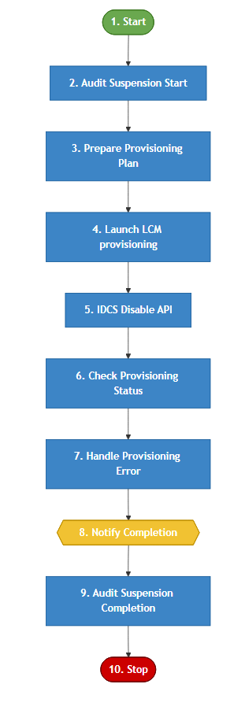

Step Summary

Voyager Suspension Workflow – Step Summary
Step No. | Workflow Step | Description
1 | Start | Initiates the workflow when the Voyager Employee Pre-Hire lifecycle event is triggered.
2 | Audit Suspension Start | Records an audit event indicating the initiation of the Employee Suspension Event
3 | Prepare Provisioning Plan | Prepares a provisioning plan to disable Identity application accounts except(EPM,UKG,Oracle HCM and PA).
4 | Process LCM Provisioning | Executes the provisioning plan through the LCM Provisioning Workflow and creates a ServiceNow incident if errors or warnings occur.
5 | IDCS Disable API | For EPM disable the account on the IDCS level by calling the IDCS API to disable the EPM Accounts.
6 | Check Provisioning Status | Reviews the provisioning results and stores any application-specific errors or warnings.
7 | Handle Provisioning Error | Errors are logged
8 | Notify Completion | Sends a Suspension completion notification to the user's manager, including any provisioning issues if present.
9 | Audit Suspension Completion | Logs an audit event to record the successful completion of the Employee Suspension Event.
10 | Stop | Ends the workflow after completing provisioning, auditing, and notification activities.

Workflow Description

Workflow:

Name : Voyager Suspension Workflow

1. Start
The workflow is initiated when the Voyager NEP Suspension event is triggered.

2. Audit Suspension Start
This step is to provide an audit trail for Voyager Suspension events. This ensures that administrators can track exactly what the user's employment status and attributes were when the suspension process was initiated.
The script follows a four-step execution pattern:
- Identity Resolution: It retrieves the Identity object from the SailPoint context using the provided identityName.
- Attribute Extraction: It pulls key profile data, including employeeType, assignmentAction, hireDate, and ministry. These attributes likely serve as the "state" of the user at the time of the event.
- Event Classification: It checks the eventName from the trigger to differentiate between a standard Associate Suspension and a NEP (Non-Employee Partner) Suspension.
- Audit Logging: If the specific audit action (VoyagerLCMEvent) is enabled in the System Configuration, it formats the collected data into a string and commits it to the audit_event table.

3. Prepare Provisioning Plan
This step serves as a Dynamic Provisioning Plan Generator for suspension workflows. Its primary role is to identify the suspension type and generate a plan to Disable all applicable user accounts while respecting a global "Ignore List."
- Workflow Routing:
  - If the event name matches "Voyager Employee Suspension," the workflow variable flow is set to Employee Suspension.
  - Otherwise, it defaults to NEP Suspension. This allows the subsequent workflow steps to apply different logic based on the user's persona.
- Exclusion Logic (Custom Mapping):
  - The script retrieves a Custom Object named Voyager UseCase Suspension Mapping.
  - It extracts a list of applications defined under the key IGNORE APP LIST. Any application in this list will be skipped during the disablement process (e.g., EPM apps).
- Account Operation Definition:
  - The operation is explicitly set to AccountRequest.Operation.Disable.
- Plan Generation:
  - The getAccountPlan helper method is called. It iterates through the user’s linked accounts and builds a plan to disable them, excluding any apps found in the appList.

4. Process LCM Provisioning
The generated provisioning plan is executed using the LCM Provisioning Workflow.
After execution:
- The ProvisioningResult of the ProvisioningProject is evaluated.
- If errors or warnings are detected:
  - A ServiceNow Incident Ticket is automatically created.
  - The ticket includes request details and error information.

5. IDCS Disable API
The step serves as an External API Integration Layer (specifically for IDCS/EPM modules) within a suspension workflow. Its purpose is to perform a suspension action in an external system via REST API
- Configuration Retrieval:
  - Fetches the Voyager UseCase Suspension Mapping Custom object to get the list of EPM Module App Names and the Target API URL.
- Account Discovery (Link Checking):
  - Iterates through the identity’s application links.
  - If a link matches an application name in the EPM MODULE APP NAMES list, it captures the user’s unique identifier (idName) for that specific system and breaks the loop.
- OAuth Authentication:
  - Calls a helper method getAccessToken(url) to retrieve a bearer token.
  - It expects a 200 OK response to extract the access_token.
- External ID Lookup:
  - Once authenticated, it calls getUserId(url, idName, access_token) to resolve the internal SailPoint ID/Name to the specific External System User ID (userId).
- API Execution (The Suspension Call):
  - Calls getResponse(url, userId, access_token, flow) to trigger the actual suspension in the external system.
  - The flow variable (Employee vs. NEP) is passed to tell the API which type of suspension logic to apply externally.

6. Check Provisioning Status
This step reviews the ProvisioningProject result.
- Any errors or warnings encountered during provisioning are captured.
- These issues are stored in an application-specific status map for reporting and notification purposes.

7. Handle Provisioning Error
Place holder to handle provisioning errors.

8. Notify Completion
A Suspension Completion Notification is sent to the user's manager.
The notification includes:
- Confirmation of account provisioning completion
- Details of any errors or warnings identified during the Check Provisioning Status step

8. Audit Event – Suspension Completion
To create a final "Success" audit event
- Identity Attribute Extraction:
  - Similar to the "Start" audit, it fetches the Identity object and pulls key attributes like workerType, assignmentStatus, and ministry.
  - Workflow Export: It specifically pulls the employeeId attribute and saves it to a workflow variable called personNumber. This ensures the ID is available for emails or logs even after the Identity object is decached.
- Audit Confirmation:
  - Checks if the VoyagerLCMEvent auditing is active.
  - Status Update: Unlike the start-of-event logic, this explicitly sets the status (string1) to "Completed - Suspension Associate Event" or "Completed - Suspension NEP Event".
  - Data Payload: Re-logs the full attribute string (worker type, hire date, etc.) to the audit_event table to provide a "final state" record.
- Transaction Finalization:
  - Calls context.commitTransaction() to ensure the audit entry is written to the database immediately.
  - Calls context.decache() to clear the Identity object from memory, maintaining system performance.

9. Stop
The workflow ends after completing all provisioning, auditing, and notification activities.

